**UNIVERSITY OF VICTORIA**

**Department of Electrical and Computer Engineering**

**ECE 403/503 Optimization for Machine Learning**

**LABORATORY REPORT**

Experiment No: 3

Title: Predicting Energy Efficiency for Residential Buildings

Date of Experiment: 25 June 2019

Report Submitted on: 3 July 2019

To: Jinlong Zhan - [jinlongzhan@uvic.ca](mailto:jinlongzhan@uvic.ca)

Laboratory Group No.: B01 - 6

Name(s):

Philippe Larocque - V00903595

Alexander Fung - V00904094

## Objectives

The objective of the lab is to build a multi-output linear model to predict energy efficiency of residential buildings. [1]

## Introduction

In order to identify the energy usage of buildings, a large data set D_build_tr.mat of 10x640 elements of building parameters and energy usage is input into a linear training model.

MATLAB software can be used to predict energy usage for a testing data set D_build_te.mat by applying it to the model built earlier.

## Results

See MATLAB code in Appedix A.

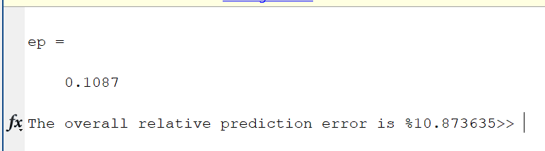

Figure 1 - Output results from code

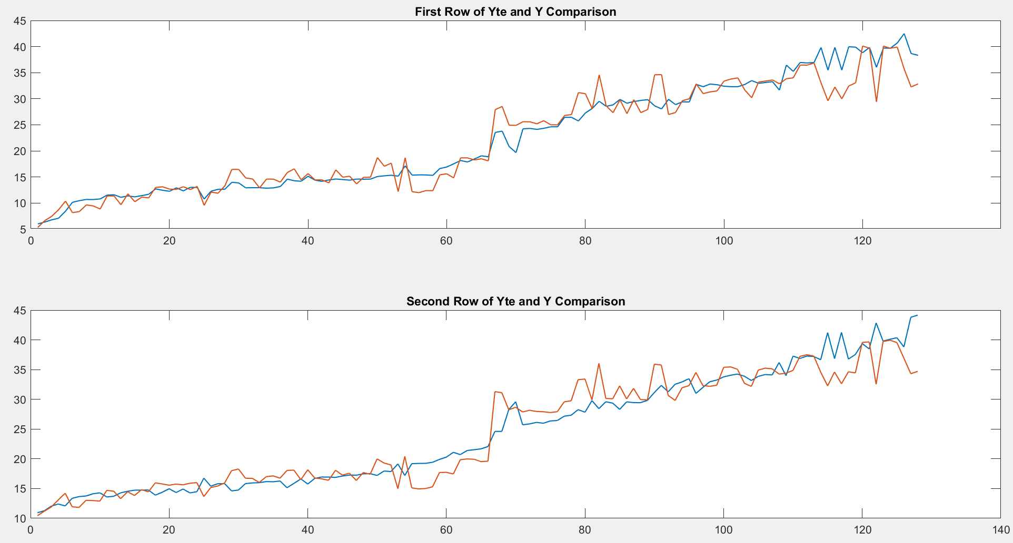

Figure 2 - Output Waveforms

## Discussion

The results of the MATLAB code takes the 8 inputs features and generates two outputs which will be compared to the true values. A set of 640 was used for the training, and 128 was used for testing.

If we plot the predicted energy usage to actual energy usage, we obtain the above waveforms. The error rate is calculated to be 0.1087, or 10.87%.

## Conclusion

The objective of this experiment was to build a multi-output linear model to predict energy efficiency of residential buildings. Based on the results, the model can predict energy usage with a 10.87% error.

## References

[1] Lu, Wu-Sheng. (May 2019). Experiment 1 - Laboratory Manual ECE 403/504 Optimization for Machine Learning. [Online]. Accessed May 2019.

<https://ece.uvic.ca/~wslu/403/403pass/Trans/LabManual-ECE403-503-2019.pdf>

## Appendix A - MATLAB code

%_________Initialization__________%

clc

clear all

close all

load D_build_tr.mat

load D_build_te.mat

%_________Separate Test and Training__________%

Xtr = D_build_tr(1:8,:);

Ytr = D_build_tr(9:10,:);

Xte = D_build_te(1:8,:);

Yte = D_build_te(9:10,:);

%_________Set XHat in the correct format and dimensions__________%

X_Hat = [Xtr' ones(640,1)];

I = eye(9);

%_________Calculate the Pseudo-inverse of X_Hat__________%

%Note, X_wierdcross was calculated WITHOUT using pinv%

%epsilon was instructed to use 0.01 from lab man.%

X_weirdCross = inv(X_Hat'*X_Hat + 0.01*(I))*X_Hat';

WB = X_weirdCross * (Ytr');

%_________Separate Wstar and Bstar__________%

W_Star = WB(1:8, :);

B_Star = WB(9,:)';

%_________Apply Optimized Model__________%

Y = W_Star'*Xte + B_Star;

%_________Calculate the overall relative prediction error__________%

ep = norm(Yte - Y, 'fro')/norm(Yte, 'fro')

fprintf('The overall relative prediction error is %%%f',ep*100)

%_________Plot the two graphs__________%

subplot(2,1,1)

plot(Yte(1,:))

hold on

plot(Y(1,:))

hold off

title('First Row of Yte and Y Comparison')

subplot(2,1,2)

plot(Yte(2,:))

hold on

plot(Y(2,:))

hold off

title('Second Row of Yte and Y Comparison')